**Green Pigeon Peas Soup**

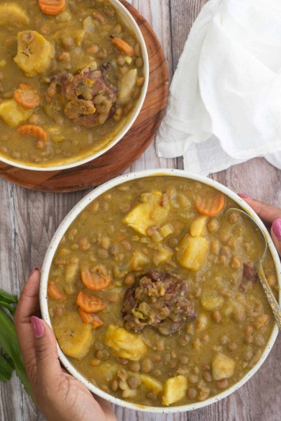

**INGREDIENTS**

1½ lb green peas  
2½ lb salted Pigtail (soaked & scald)  
2 – 4 cups of coconut milk optional not a must  
8 – 10 cups of water  
½ – 1 lb dumplings  
3 – 3 lbs ground provisions 9 sweet potatoes, yam, tannia eddoe, etc)  
1 large onion sliced  
2 cloves garlic  
2 sprigs chive and thyme  
3 seasoning peppers chopped  
8 – 10 whole cloves or ¼ tsp ground clove  
Salt and pepper to taste

**METHOD**

1. Clean peas and boil with meat, cloves, and coconut milk till peas is tender.
2. Prepare vegetables and add to pot with other ingredients.
3. Cook on low heat till done. Add more water if necessary.